A000-AM,S-Ecuador-Valdivia-Mother and Infant-3500-2000 BCE

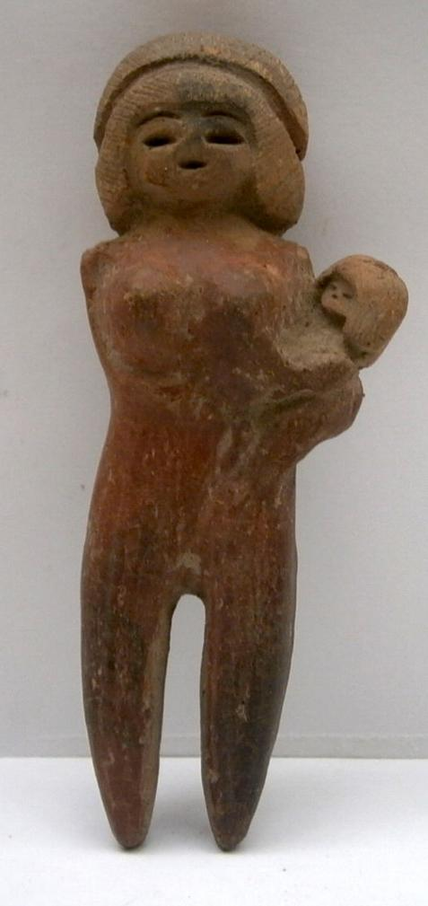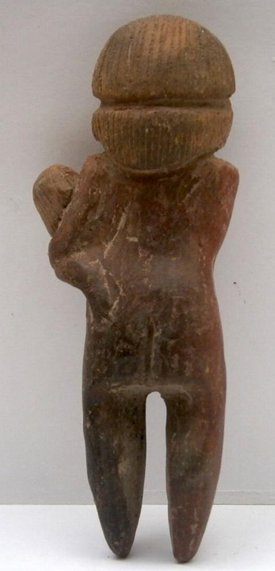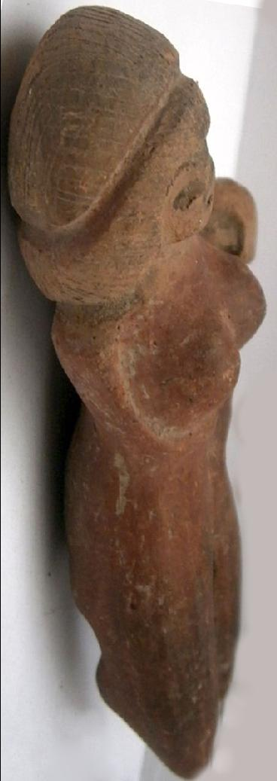

Figs. 1-3. Ecuador-Valdivia-Mother and Infant-3500-2000 BCE

**Case No.: 9**

**Accession No.**

**Formal Label:** AM,S-Ecuador-Valdivia-Mother and Infant-3500-2000 BCE

**Display Description:**

Female ceramic votary figurine from South Coast of Ecuador dating 3500-2000 BCE. The legs of this figurine are pointed to enable it to stand in a bed of sand such as where a shrine would be placed in a domicile.

The Valdivian culture was discovered in 1956 on the western coast of Ecuador by the Ecuadorian Emilio Estrada, who continued to study this culture. American archeologists Clifford Evans and Betty Meggers joined him in the early 1960s in studying the type-site.

Valdivians lived communally thatched huts around a central plaza. As they were sedentary agriculturists and fishers who hunted for deer to supplement their diet of cultivated maize, kidney beans, squash, cassava. The culture has been classified as representing a "tropical forest culture" with a riverine settlement focus. Cotton was processed, spun and woven to make fine weave clothing.

Female votary figurines were a trademark of their culture.

**LC Classification:**

**Date or Time Horizon:** 3500-2000 BCE

**Geographical Area: Valdivia site,** South Coast of Ecuador

**Map:**

**GPS coordinates:**

**Cultural Affiliation:**

**Medium: ceramic**

**Dimensions: H** 3.66 in - 9.3 cm

Weight:

**Condition:**

**Provenance:**

**Discussion:**

**References:**